University of Puerto Rico - Mayaguez Campus

Department of Electrical and Computer Engineering

ICOM 5016 - Introduction to Database Systems

Professor: Manuel Rodriguez

**Term Project – Backend System for Disaster Site Resources Locator**

**Phase II – Conceptual Design**

By:

Nicole Matos Feliciano

Gilissa Matos Hernández

December 5, 2017

Entity-Relationship Model

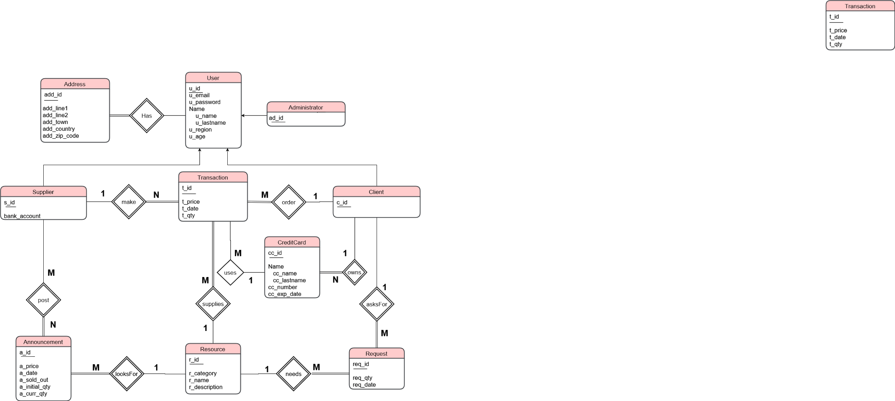

Schema Design with E-R Model

create table user_table( -- user of system (inherit administrator, supplier and client)

u_id serial primary key, -- user id

u_email varchar(50), -- user email

u_password varchar(20), -- user password

u_name varchar(20), -- user name

u_lastname varchar(20), -- user last name

u_region varchar(20), -- user location

u_age int -- user age to see if user is older than 18 years old

);

create table address( --address of user

add_id serial primary key, --address id

u_id integer references user_table(u_id), --user id

add_line1 varchar(25), --address line 1

add_line2 varchar(25), --address line 2

add_town varchar(20), --address town

add_country varchar(20), --address country

add_zip_code char(5) --address zip code

);

create table administrator( -- administers the system (inherited from users)

ad_id serial primary key, -- administrator id

u_id integer references user_table(u_id) -- user id

);

create table supplier( -- supplies by announcements (inherited from users)

s_id serial primary key, -- supplier id

u_id integer references user_table(u_id), -- user id

bank_account integer -- supplier bank account

);

create table client( -- client get donations or purchases (inherited from users)

c_id serial primary key, -- client id

u_id integer references user_table(u_id) -- user id

);

create table credit_card( -- credit card registered by a supplier (can own more)

cc_id serial primary key, -- credit card id

c_id integer references client(c_id), --client id

cc_name varchar(20), -- credit card name

cc_lastname varchar(20), -- credit card last name

cc_number integer, -- credit card number

cc_exp_date Date -- credit card expiration date

);

create table resource( -- resource of system

r_id serial primary key, -- resource id

r_category varchar(20), -- resource category

r_name varchar(20), -- resource name

r_description varchar(50) -- resource description

);

create table transaction( -- transaction made between supplier and client

t_id serial primary key, -- transaction id

s_id integer references supplier(s_id), -- supplier id

c_id integer references client(c_id), -- client id

r_id integer references resource(r_id), --resource id

t_price float, -- transaction price

t_date Date, -- transaction date

t_qty int -- transaction quantity (of resources)

);

create table announcement( -- announcement made by a supplier

a_id serial primary key, -- announcement id

s_id integer references supplier(s_id), -- supplier id

r_id integer references resource(r_id), --resource id

a_price float, -- announcement price per unit

a_date Date, -- announcement date

a_sold_out boolean, -- announcement status (if sold out or not)

a_initial_qty int, -- announcement initial quantity

a_curr_qty int -- announcement current quantity

);

create table request( -- request made by a supplier

req_id serial primary key, -- request id

c_id integer references client(c_id), -- client id

r_id integer references resource(r_id), --resource id

req_qty int, -- request quantity

req_date Date -- request date

);

Relationships

1. **make** - This is a one to many relationship, since an element from entity Supplier is related with more than one element from entity Transaction. A supplier can have many transactions, but a transaction can only be part of one supplier. In this relationship Transaction must have total participation and is declared a weak entity.
2. **needs** - This is a one to many relationship, since an element from entity Resource is related with more than one element from entity Request. A resource can be requested many times, but a request can only be about one resource. In this relationship Request must have total participation and is declared a weak entity.
3. **asksFor** - This is a one to many relationship, since an element from entity Client is related with more than one element from entity Request. A client can have many requests, but a request can only be made by one client. In this relationship Request must have total participation and is declared a weak entity.
4. **order -** This is a many to one relationship, since an element from entity Client is related with more than one element from entity Transaction. A client can have many transactions, but a transaction can only be order by one client. In this relationship transaction must have total participation and is declared a weak entity.
5. **uses -** This is a many to one relationship, since an element from entity Credit Card is related with more than one element from entity Transaction. A credit card can be used many transactions, but a transaction can only be placed with one credit card.
6. **owns -** This is a many to one relationship, since an element from entity Client is related with more than one element from entity Credit Card. A client can own many credit cards, but a credit card can only be owned by one client. In this relationship Credit Card must have total participation and is declared a weak entity.
7. **supplies -** This is a many to one relationship, since an element from entity Resource is related with more than one element from entity Transaction. In this relationship Transaction must have total participation and Transaction is declared a weak entity.
8. **looksFor -** This is a many to one relationship, since an element from entity Resource is related with more than one element from entity Announcement. In this relationship Resource must have total participation and Announcement is declared a weak entity.
9. **post -** This is a many to many relationship, since an element from entity Supplier is related with more than one element from entity Announcement. Likewise, an element from entity Announcement is related with more than one element from entity Supplier. In this relationship Announcement must have total participation and Announcement is declared a weak entity.